 | 7.0.15 Editors - 3D Viewport - Grease Pencil object - Draw Mode - Brushes context menu
Table of content
Draw Mode - Brushes Context Menu 1
Radius 1
Strength 2
Active Layer 2
Layer drop down box 2
New Layer 2
Layer Edit Box 2
Remove Layer 2
Show/Hide Dropdown 2
Show All Layers 2
Hide Active Layer 2
Last Operator Hide Layer(s) 2
Unselected 2
Hide Inactive Layers 2
Active Material 2
Material drop down box 3
Material Edit Box 3

Draw Mode - Brushes Context Menu

Call this menu with double right click in the 3D viewport. You need to be in Draw mode with a grease pencil object.
In Draw mode you will call a context menu with the sliders from the Brush settings.
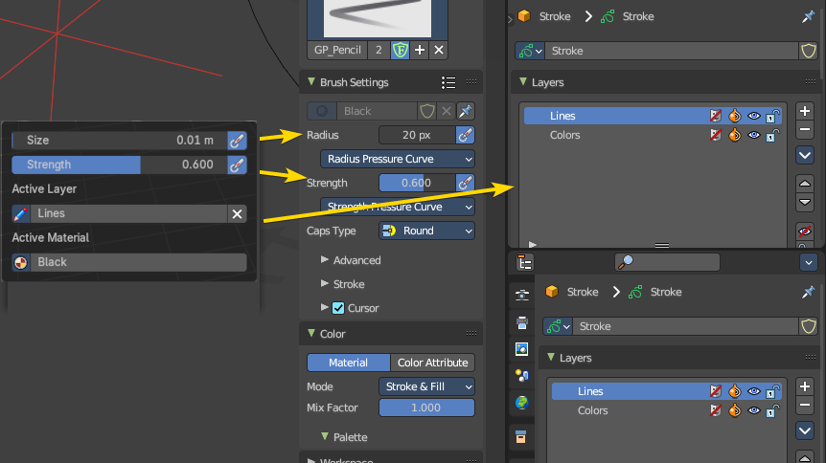

Radius
The radius of the sculpt brush.

Strength
The strength of the sculpt brush.

Active Layer
The active grease pencil layer. You can choose another layer, and add new layers here too. It is the same content than in the Properties editor.

Layer drop down box
The list of available layers.

New Layer
Add a new grease pencil layer.

Layer Edit Box
The currently active grease pencil layer. Rename it by clicking into the field.

Remove Layer
Remove the grease pencil layer.

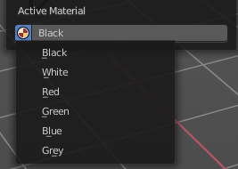
Active Material
The current active material.

Material drop down box
The list of available materials.

Material Edit Box
The currently active material. Rename it by clicking into the field.

